# Fall 2018: EEL-6935 Smart Grid – Homework 03

Hector Lopez

11/11/2018

**1. Short Answers. [30 pts]**

1. Give two reasons why the slack bus is needed for the power flow analysis.
   1. A slack bus is used to set the reference angle for all other buses in a system.
   2. The angle for the slack bus is usually set to 0 for convenience.
   3. After all output power is calculated any extra power loss that is not accounted for is assigned to the slackbus.
   4. It is the reference where the magnitude and phase angle of the voltage are specified.
   5. For most systems the slack bus is chosen to be the bus with the largest generating station.
2. What is the purpose of power system economic dispatch, and what is a necessary condition for an economic dispatch of the generation
   1. The optimal output of a multiple generators trying to meet the system load at the lowest possible cost.
   2. The constraints are the transmission lines and plant operation limits.
   3. This dispatching process tries to minimize the total cost of fuel to while meeting the load demand.
3. Over the last decade or so what are some of the new visualization techniques that have been applied for displaying power flow results? (You may need to search online papers/report for answering this question)
   1. **Animated arrows** are an intuitive understanding of the flow of power in a transmission system network. The size, orientation and speed of the arrows indicate the direction and magnitude of the power flow on the transmission lines. This visualization technique provides an immediate understanding of the transmission system to a new engineer or non-technical audiences.
      1. 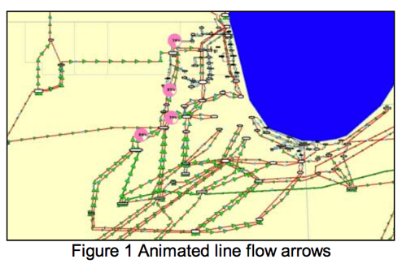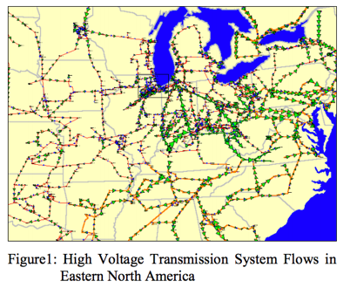
   2. **Dynamically sized pie charts** are used to assess location and magnitude of line overloads at a glance. The percentage fill of the pie charts shows how close the transmission line is to overload.
      1. 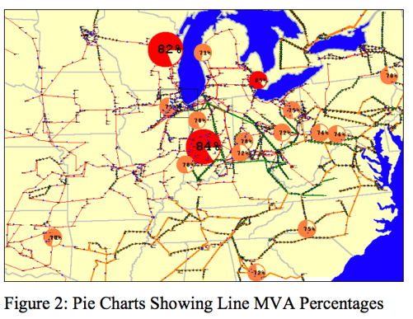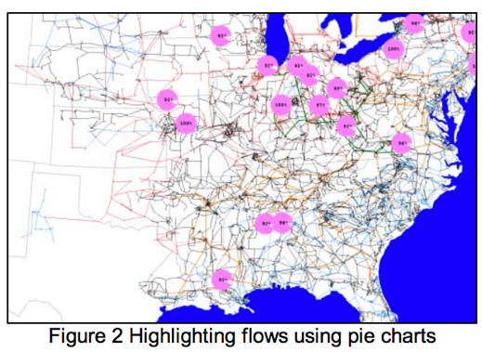
   3. **Contouring** is used to represent spatially distributed data. The equal-temperature contours in a newspaper weather report are a common example. Contouring can be used to analyze system security information as well as power market information.
      1. 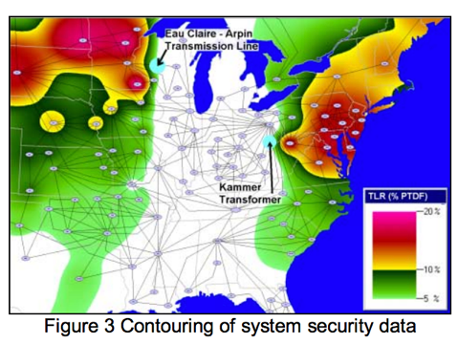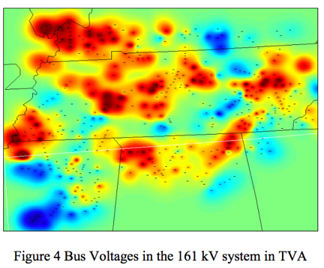
   4. **Flowgate Visualization** is a data aggregation technique currently advocated by the North American Electric Reliability Council (NERC). A collection of transmission system branches. A common flowgate is the sum of the tie line flows between two areas. Ovals are drawn which represent a control area. The flowgates can also be combined with contour visualization.
      1. 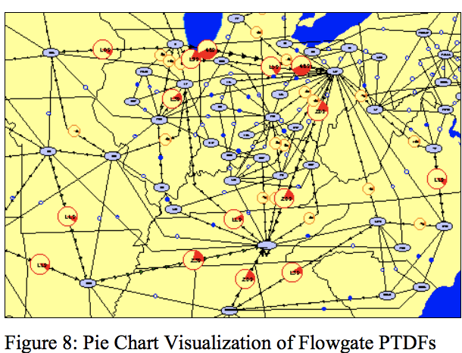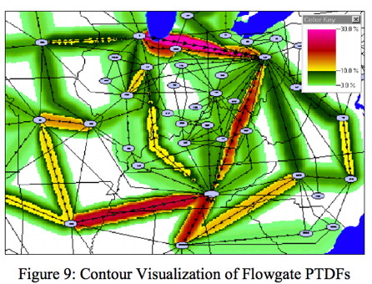
   5. **Virtual Reality Data Visualization** can be used to show relationships between layered system needs such as the actual transmission system flows and the scheduled contractual flows. Virtual reality can be used to try to visualize these complex relationships.
      1. 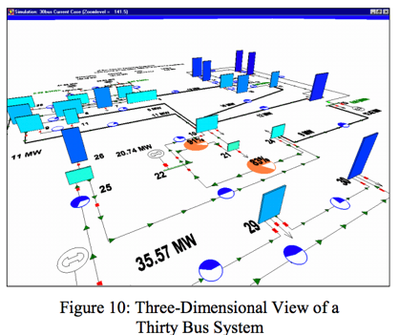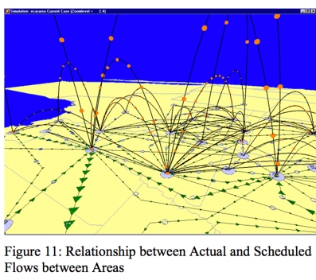

**References**

1. *Visualization of Flows and Transfer Capability in Electric Networks;* Thomas J. Overbye, James D. Weber overbye@uiuc.edu jd-weber@uiuc.edu Department of Computer and Electrical Engineering University of Illinois at Urbana-Champaign Urbana, IL 61801 Mark Laufenberg lauf@powerworld.com PowerWorld Corporation Urbana, IL 61801
2. *Real-Time Data Retrieval and New Visualization Techniques* *for the Energy Industry*; Raymond P. Klump Lewis University and PowerWorld Corporation Urbana, IL 61801 USA ray@powerworld.com James D. Weber PowerWorld Corporation Urbana, IL 61801 USA weber@powerworld.com

**2. DC Power Flow Approximation. [30 pts]**

As discussed in class, DC power flow is a linearized approximation to AC power flow, where we assume that, line resistances are zero, voltage magnitudes are equal to one, and voltage angles are small, so that cos 1.0 θ ≈ and sinθ ≈ θ for all θ . In this problem, you will derive the simplified expressions for DC Power Flow. In particular, show that under the DC Power Flow assumptions: p=-B θ, q=0 where B is the imaginary part of the admittance matrix formed using these approximations.

Set the DC approximations :

* + - * All bus voltage magnitudes are sufficiently close
      * No active power loss on transmission lines
      * All bus voltage angle differences are sufficiently small

Using the definitions for Conductance and Subceptence :

Apply assumption that for all values of

Notice that for all values of k:

The cases shows that the imaginary part of the Admittance matrix is required for real and reactive power at all angles of theta.

**--- Note: not the final proof for DC equaitons.**

**3. Power System State Estimation [40 pts]**

A one-line diagram of the 3-bus system discussed in the class is shown below. Assume that we have one meter installed on each line to measure the power flows. Please solve the three questions below regarding the power system state estimation.

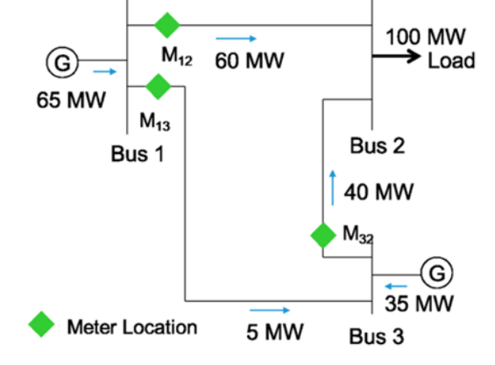

1. Assume all meter readings are correct.

What are the voltage angles at each of the three busses, assuming the reference angle is , .

|  |  |
| --- | --- |
| Per Unit Reactance (100 MVA Base): | Per Unit Flow (100 MW Base): |
|  |  |
|  |  |
|  |  |

Use the as the reference angle:

1. Now, assume that each meter has the same noise variance 𝜎2 . We would like to estimate the voltage angles (the state variables) using the line power flows (the measurements). According to the state estimation problem, 𝐱 = [𝜃1, 𝜃2, 𝜃3] and 𝐳 = [𝑃12, 𝑃13, 𝑃32], and the state estimation equation is:

Let

Assume:

, ,

The topology matrix H is m-by-n , where m is the number of measurements ,3 and n is the number of state variables in x , 5.